 Invoice
Invoice no / Customer no  8819 2445 | Invoice date  2011-10-03

Invoice Address

Novus Scientific AB
Rapsgatan 25

754 50 Uppsala
Delivery Address

Novus Scientific AB
Rapsgatan 25

754 50 Uppsala

Your reference contact Fredrik Preinitz Our reference contact Kate Schröder
Your order no. Payment terms 20 days net
Delivery terms Free our inventory Due date 2011-10-23
Means of delivery Mail Late fee 10.00%

Item no Description Units delivered Cost Mk Total

SW-593 SolidWorks® Prof
current s-agreement 1 18,360.00 1 18,360.00

Intended for serial no. 9000 0083 5315 6050

Agreement in effect 2011-11-01 until 2012-10-31

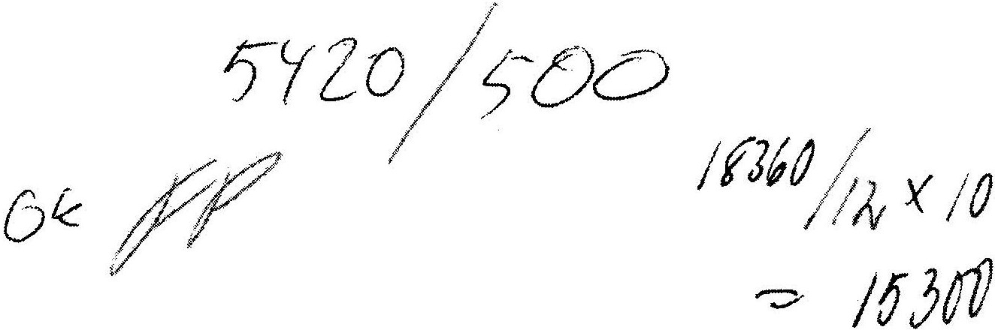

Taxed amount 25% 18,360.00
Tax SEK 25% 4,590.00
Net TOTAL AMOUNT DUE
18,360.00 22,950.00

Address Telephone Internet
SolidEngineer AB 08-544 730 20 www.solide.se
Enhagsslingan 1A Fax Bank giro Email
187 40 Täby 08-792 23 12 5089-8840 kate.schroder@solide.se
Company seat Corp ID no Tax ID no
Täby 556671-2740 SE556671274001
F-tax certificate holder

SolidEngineer AB retains the right to retrieve any delivered items until payment has been made in full.

