

Invoice

Invoice no
F9474

Page
1

Delivery Address

Novus Scientific AB Roger Johansson Rapsgatan 25
751 38 Uppsala
Novus Scientific AB Roger Johansson
Rapsgatan25
754 50 Uppsala

Account no | K10400 | Our order no OR3032
Invoice date | 11-10-14 | Your reference | JACOB JOVELOU
Payment terms  Due date | 30 days net  11-11-13 | Your order no  Delivery terms | Free our inventory
Our reference | Daniel Thunberg | Project

After the due date a late fee will be applied of 8% yearly. Any disputes to this invoice should be made no later than 8 days after invoice date to the above assigned reference. Late fee will apply according to existing regulations.

Item no | Description | No of Units | Type of work | Cost | Amount
14042799 | License renewal  SYMC ENDPOINT PROTECTION | 13 Pieces |  | 225.00 | 2925.00
 | 11.0 RENEWAL BASIC 12M
731-01323 | Microsoft Office for Mac-Lic | 3 Pieces |  | 1,566.00 | 4,698.00
W06-01504 | LIC/SA PK NL 1YR ADD PROD Microsoft Core CAL- License-o | 18 Pieces |  | 563.00 | 10,134.00
 | CAL-Platform-OVS-WIN-AII Lang
76J-02597 | Microsoft Office Enterprise- | 13 Pieces |  | 1,586.00 | 20,618.00
 | LIC/SA PK 1Y
66J-06925 | Microsoft Windows 7 | 13 Pieces |  | 612.00 | 7,956.00
 | UPGRADE/SA PACK 1Y
P73-01608 | Microsoft Windows Server Stand* |  |  | 2,670.00 | 2,670.00
 | 1 server-OVS-AII Languages
OE710ZFO-BI1E | Symantec Endpoint Protection- | 2 Pieces |  | 410.00 | 820..00
 | V12.1USR BNDL STD LIC BASIC 1



Tax 25% on 49,821.00 SEK 12,455.25

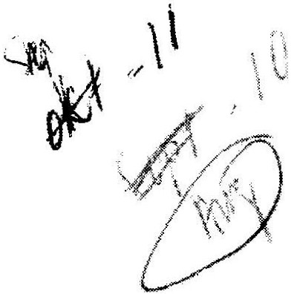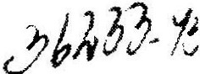Total SEK before tax
Rounded to nearest
Total SEK with tax
49,821.00
-0.25
62,276.00

Xite Consulting AB Box 2045
750 02 Uppsala
Telephone
018-4308030
Internet www.xite.se
VAT number
SE556665183101

Company is holder of F-tax certificate
Bank giro
5855-6432

