
52110

Invoice date 2011 01 21

LEIF BOLANDER & CO AB
018-567100
Novus Scientific AB Rapsgatan 25

Internet
www.trygghansa.se
754 50 UPPSALA

Invoice for company owned car

Corporate ID no
FC>Insurance no
FC>Insurance intended for:
Insurance period:
Due date:
Yearly fee: Traffic
Taxed traffic
Partial insurance
Interruption
556774-5442
031 671 991
Skoda Oct Com El 1,6 Tdl with reg.no KEN138
2011 03 01 – 2012 02 29
2012 03 01
3,896.00 SEK including tax
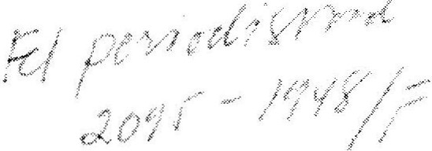1,970.00 SEK
630.00 SEK
1,140.00 SEK
156.00SEK

Description

Period Amount

Cost for period
Tax car insurance
2011 03 01 – 2011 08 31
2011 03 01 – 2011 08 31
1,63300SEK
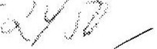 315.00 SEK

Total amount due

1,948.00SEK

For calculation of costs, the following has been taken into consideration
-Partial fee payment

The fee is applied to the next period.
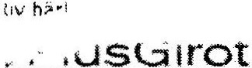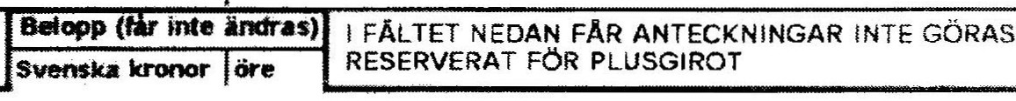

Please make payment before 2011 03 01

PAYMENTITRANSFERC Code1

ForPlus Giro acct
495 91 02-7
Recipient

TRYGG-HANSA
Fee

Amount to be received by us no later than 2011 03 01
Insurance acct no 031 671 991

For payments by any other means use ref 03167199110
Sender(nameandmailing addressornumber)
Novus Scientific AB Rapsgatan25
75450 UPPSALA

Messages to recipient cannot be left on this form
NO NOTATIONS CAN BE MADE IN THE SPACE BELOW SERVERVEDFORPLUSGlROT
Account no during transfer

03167199110 # 2095 00 8> 49591027 #14#

