TGL – Jan-Feb Issue-RWM
- RWM Cover
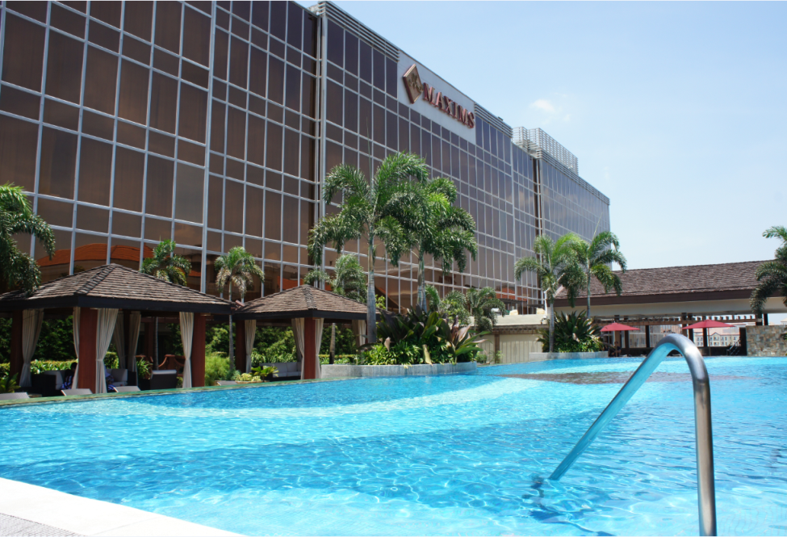

All Suite Stay at Maxim's Hotel

From the upscale Asian lodging brand of the Genting Group, Maxims Hotel is the all-suite luxury hotel in the Philippines, setting the benchmark for high-end accommodations in the country. Catering to guests with the most discerning tastes, this first-class city retreat is equipped with 172 spacious and lavishly-furnished suites.
Complementing the plush amenities is its impeccable, personalized service. Each room is assigned a butler to attend to the guests’ every need, from their itinerary to dining reservations, 24 hours a day.
For VVIPs, there are three royal villas available. A Maxims Hotel Royal Villa offers over 500 square meters of personal leisure space, with a magnificent pool, impressive patio, and an elegant kitchen and dining room for you to hold your intimate dinners. Adding to its enticing indulgences, each Maxims Hotel Royal Villa has its own massage room, offering a relaxing respite to hotel guests.
The pinnacle of luxury at Maxims Hotel is its Presidential Suite. This 600 square-meter suite is a veritable urban oasis with two pavilions, its own lush garden and a private swimming pool. Only the choicest amenities ensure utmost comfort in its two spacious bedrooms with individual bathrooms, and the master bathroom with its own jacuzzi. The Maxims Hotel Presidential Suite is the ultimate luxurious escape, with its private massage room, visual room, bar and other top-of-the-line features that will surely make your stay a one-of-a-kind experience.
For inquiries and reservations, Call us at:
+63(2) 908 8000 loc 7796 to 7797
+63(2) 908 8600
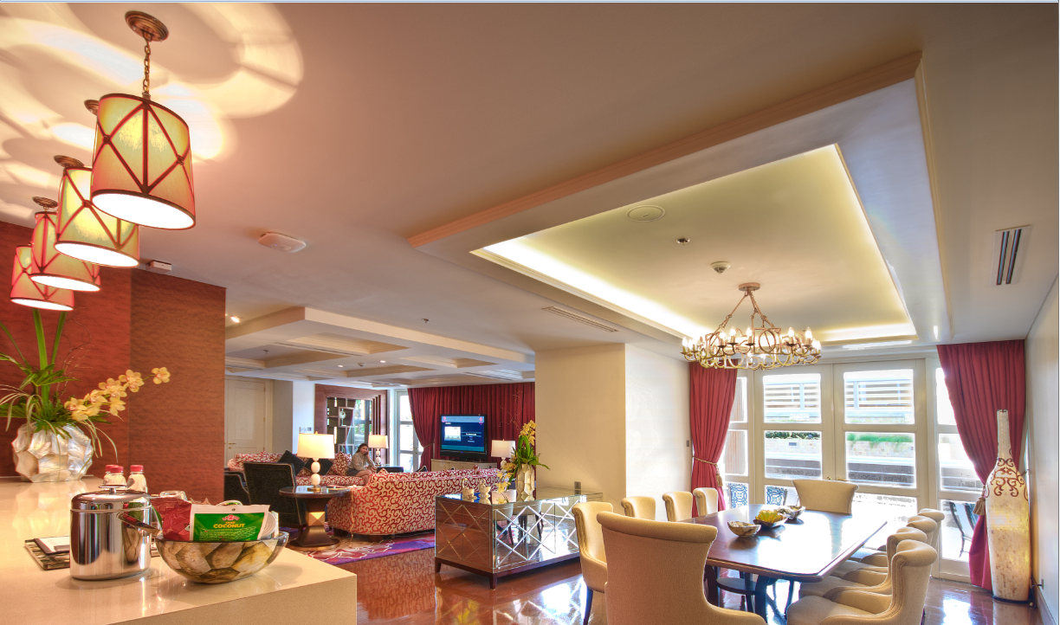

Banner Ad

iGrab

Exclusive Online Shopping UP TO 75% OFF on Limited Offers

Enjoy an online shopping site that provides access to handpicked products, services, and experiences at special prices.

iGrab is exclusive to its members, but signing up is free. Register Now! and start shopping online! visit www.igrab.ph


- RWM Exclusive Dining Guide

A. Dine with Points
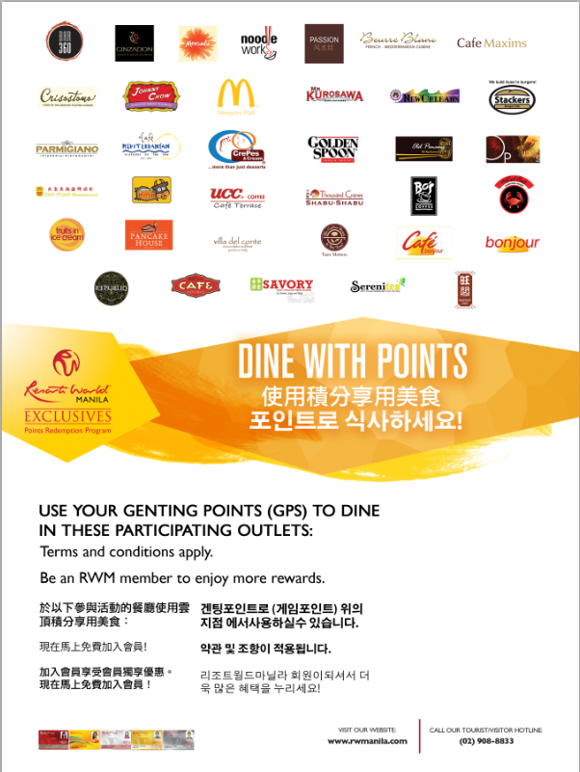

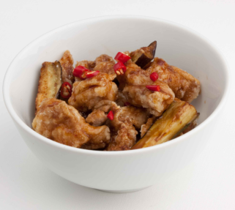

B. Recipes


Recipes' bestseller, General's Chicken, has deep fried chicken fillets and eggplant slices with Recipes' own sweet spicy sauce. General's Chicken (Not Spicy) and General's Tofu are also available.

C.. Krazy Garlik
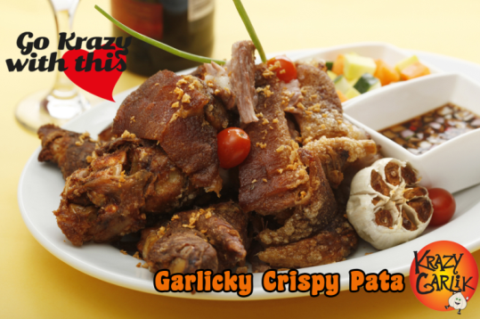
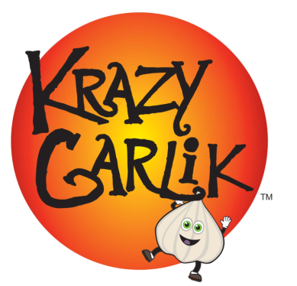
Go on a garlic adventure! Krazy Garlik brings together the best garlic recipes from around the klove.

Contact Details:
Krazy Garlik, Newport Mall, 2nd Level
(02) 621-7148

D. Savory Chicken


Our celebrated chicken is marinated in special seasoning and spices then fried to perfection. For a truly delighted Savory experience, indulge in our timeless gravy as you take tender bites from our juicy and tasty recipe.

Contact Details:
Newport
407-8384

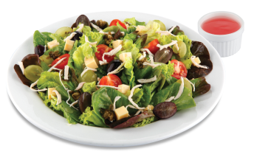
E.Pancake House


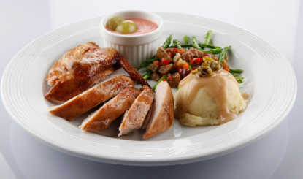

Roast Chicken with Grape Sauce is a roast chicken with a special grape sauce and two side dishes of mashed potato topped with fried capers and asparagus with grape-veggie salsa.
Grapes and Greens Chicken Salad is a fresh mixed greens tossed with black & green grapes, roast chicken strips, cherry tomatoes, cheddar cheese and fried capers. Served with a refreshing raspberry vinaigrette.
Contact details:
G/F Star Cruises Centre (Across Naia 3)
100 Andrews Ave., Newport City, Pasay
Tel. No. 836-9261
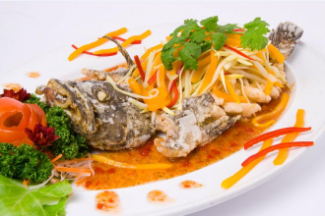
F.Tao Yuan (you can use more photos)


End your search for the best Hainanese Chicken Rice in town

G. Thousand Cranes (you can use more photos)
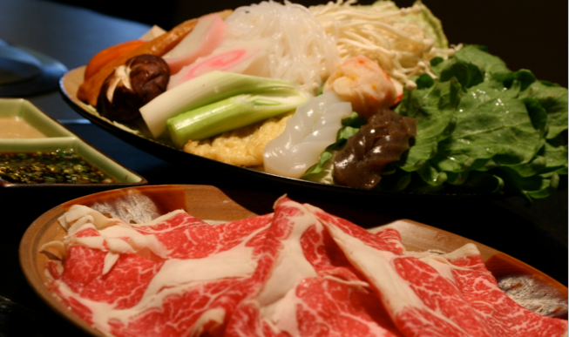

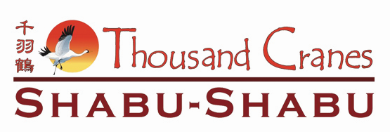

Bond over a hearty shabu-shabu meal made with the freshest ingredients and cooked right at your table.
Tel No:(+632) 621 0979
Operating Hours: Daily, 11:00 a.m. - 12:00 m.n.
Location:4th Level, Newport Mall

H. Golden Spoon


New flavor - st patrick's mint - "Get the luck of the Irish with this mighty minty treat."
Jan-Feb flavor - fresh blueberry -" Enjoyed with great popularity around the world in cuisines from Asia to the Mediterranean, our blueberry flavored frozen yogurt is spot on with this nutritional powerhouse."
Golden Spoon Newport,
4th Floor Wall Shop 01,
Newport City, Pasay City
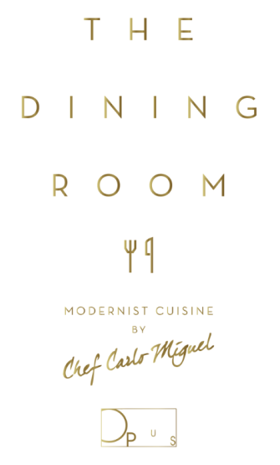
I. Opus
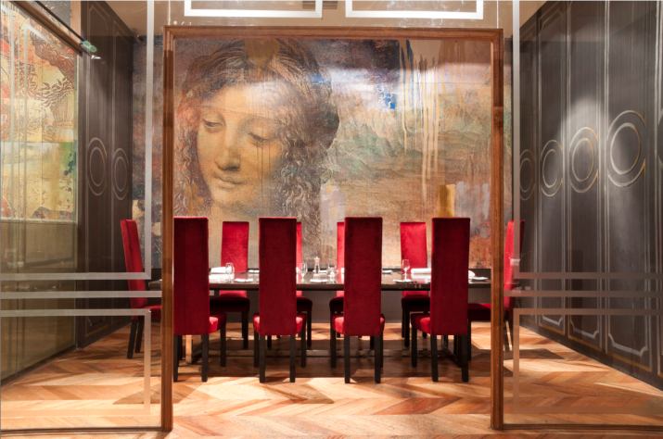

At The Dining Room at Opus, Chef Carlo Miguel takes his brand of modern European cuisine to the next level through forays in molecular gastronomy. It's not fine dining, he insists. It's fun dining!

- RWM Events and Entertainment

  - Club Mwah


Catch Follies De Mwah at 8 PM this October 29, 30 and 31; November 5, 6, 7, 12, 13 and 14; and January 2, 3, 9, 10, 16, 17, 23, 24 and 31 at the Newport Performing Arts Theater!
Follies De Mwah is the resident performing group of Club Mwah (located along Boni Avenue in Mandaluyong City) which has received acclaim for its Las Vegas, Moulin Rouge and Broadway-inspired musical productions, created, choreographed and directed by Cris Nicolas.
In store for Resorts World Manila audiences are lavish numbers starting off with a take on Madonna’s Super Bowl Halftime Show; a spoof of Rodgers and Hammerstein’s The Sound of Music; Diamonds Are Forever, the Moulin Rouge version; and a whole lot more!
Visit www.rwmanila.com for more details


  - Dance Wednesdays

Enjoy an evening of ballroom dancing and groove to the rhythm of the 60s, 70s and 80s as Resorts World Manila presents Dance Wednesdays.
Join us every Wednesday as the Spirit of 67 livens up the dance floor at Bar 360, featuring Kokoo Gonzales, Zoe Zuniga, Charlie Ysmael, and Tony Sabalza. And to make sure you are grooving to every beat, dance instructors will be on the floor to help you with your moves. Party the night away and sing along with the Spirit of 67 only at Bar 360!
Visit www.rwmanila.com for more details

- RWM Exclusives Shopping Guide
  - Shop with Points
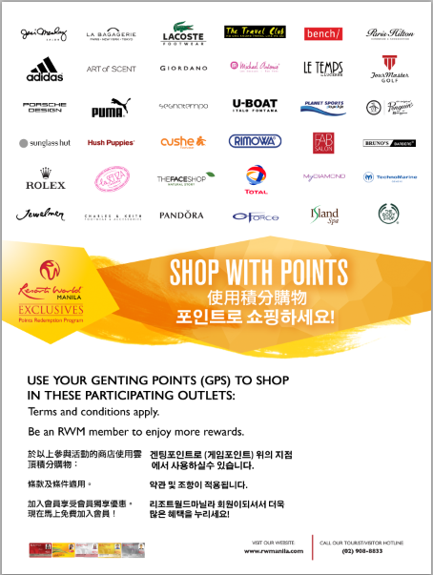

B. Velvet Salon by Jing Monis
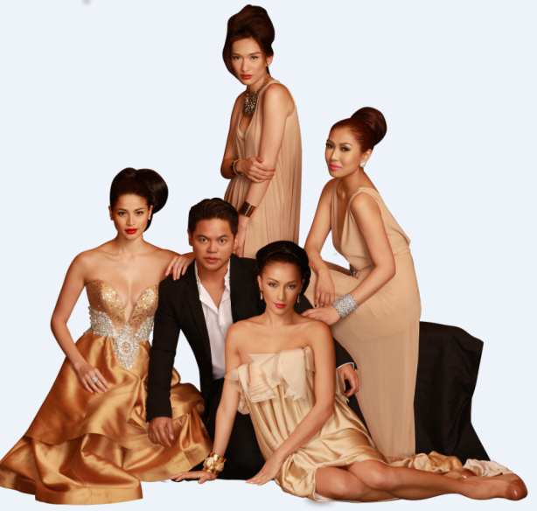

Jing Monis' mission in life is simple: "To bring out the true beauty that lies within each woman/man through my craft." Versatility is also shown in the new prestigious location, with its talented and creative team of Jing Monis Salon Velvet. We are ready to help you recreate your image and make you feel like royalty.

www.thejingmonissalon.com

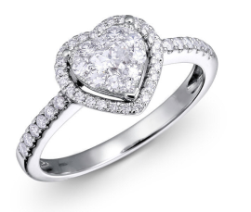
C. My Diamond

My Diamond is a concept boutique specializing in stylish white gold and diamond jewelry. My Diamond appeals to young, empowered women with discerning tastes and who know what they want in life.
Ground Floor Maxims Hotel

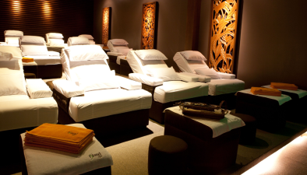

D. ISLAND SPA- A Refreshing Haven

Immerse yourself in Island Spa’s Zen-like ambience and the soothing feeling of well-trained hands to envelop you in feeling of total relaxation, rejuvenation and wellness.
Island Spa offers authentic Chinese Therapeutic Foot Reflexology, Shiatsu, Swedish, Deep-Tissue Massage, Aromatherapy and Volcanic Rock Massage.
Refresh and rejuvenate the senses at Island Spa, an oasis in the midst of the city.

---------------------------------------------------------END---------------------------------------------------------------------

