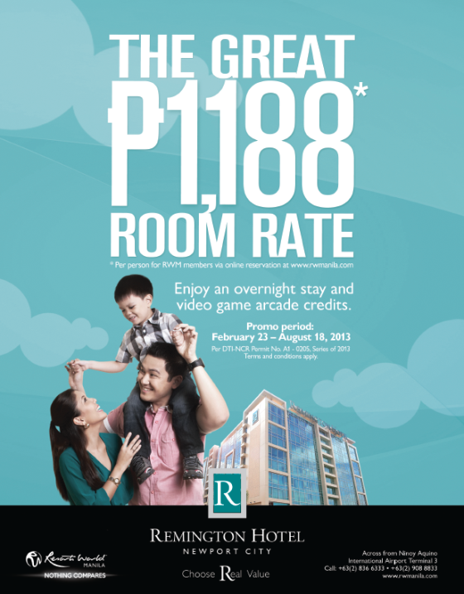

The Great PHP1188* Room Rate at Remington Hotel

Choose real value and take advantage of Remington Hotel's killer deal! Stay overnight for only P1,188 per person and get free video game arcade credits.
Why Choose Remington?
There’s a place for everyone at Resorts World Manila, and that includes smart travelers who makes the most out of each experience. Designed for the smart traveler, Remington Hotel offers superb accommodations at real value.
- Located right across NAIA Terminal 3 and a few minutes away from NAIA Terminals 1 and 2
- A 15-minute drive from the Makati and Fort Bonifacio commercial districts
- 24/7 free airport shuttle service every hour, on the hour
623 Standard Rooms
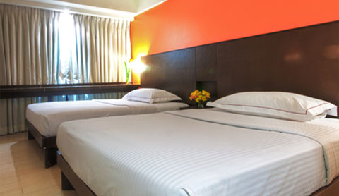
- Two queen size beds
- Average room size of 21 sqm
- 32 inch LCD television with cable
- Hot and cold shower and bathroom with bidet spray
- Bathroom amenities include dispenser, shampoo, bath gel, hand soap and tissue paper
- Standard bed linen and 2 bath towels
- Closet
- Electronic door and keycard system
- In-room safety box
- In-room telephone (room to room only)
- Individually controlled airconditioning units
- 220V universal sockets
- Daily make-up room service from 8AM to 3PM
- Maximum occupancy of 2 adults and 2 children below 12 years
89 Serviced Apartments
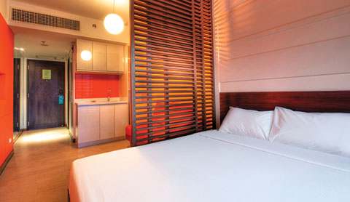
- One queen size bed
- Sofa bed
- 32 inch LCD television with cable
- Refrigerator and electric kettle
- Hot and cold shower and bathroom with bidet spray
- Bathroom amenities include dispenser, shampoo, bath gel, hand soap and tissue paper
- Standard bed linen and 2 bath towels
- Closet
- Electronic door and keycard system
- In-room safety box
- In-room telephone (room to room only)
- Individually controlled airconditioning units
- 220V universal sockets
- Daily make-up room service from 8AM to 3PM
- Maximum occupancy of 2 adults and 2 children below 12 years
Hotel Information
- Check-in time is 2PM
- Check-out time is 12:00 noon
- 24 hour CCTV security
- Designated Smoking and Non-Smoking floors and areas – A PHP1,000 penalty will be charged for smoking in non-smoking rooms
Other Services
- WiFi Connection - charges apply
- Luggage storage and assistance
- Local, NDD and IDD telephone access - charges apply
- Hairdryer – PHP500 refundable deposit
- Microwave oven (for serviced apartments only) - upon request
- Basement parking - charges apply
- Laundry services - charges apply

A. Republiq


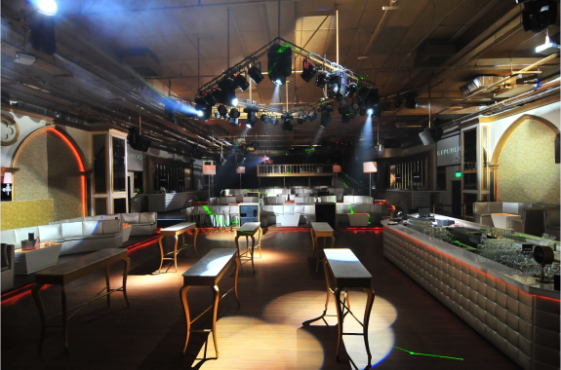
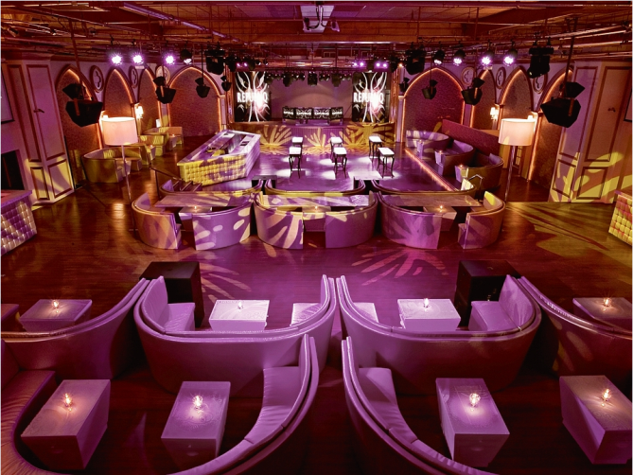

Located at Resorts World Manila, the premiere entertainment and gaming complex in the Philippines, REPUBLIQ CLUB is the number one nightlife destination in the country. With over thirteen thousand square feet of clubbing space, REPUBLIQ is one of the biggest dance clubs in Asia.

Since it’s opening in June 2010, REPUBLIQ has brought in the world’s biggest DJs
including Avicii, Afrojack, Fedde Le Grand, Kaskade, Calvin Harris, Ferry Corsten and
Benny Benassi among others. Performing artists such as LMFAO, Far East Movement, Jay Sean, Dev and Lil Jon have also taken the stage.

Adorned with the most luxurious of furnishings and décor along with the latest sound,
lighting and visual technology, REPUBLIQ promises its patrons a true world-class clubbing experience.

Adjacent to the main dance hall is the Cabana Club, a separate clubbing space housing seven private rooms that will cater to only the most distinguished guests. An indoor waterfall behind the DJs booth acts as the main focal point of the room. Cabana Club guests can expect full service private rooms, each with its own restroom, LED TV, sound system, and minibar as well as a dedicated host to attend to all clubbing needs.

Website: www.republiqclub.com
Facebook: www.facebook.com/REPUBLIQ.CLUB

Twitter: @REPUBLIQ_
- Tel No:(+632) 856 1299
- Operating Hours:Wild Wednesdays, Soiree Fridays and Pure Saturdays: 9:00 p.m. - 5:00 a.m.
- Location: 2nd Level, Newport Mall

A. Dance Wednesday

Enjoy an evening of ballroom dancing and groove to the rhythm of the 60s, 70s and 80s as Resorts World Manila presents Dance Wednesdays.
Join us every Wednesday as the Spirit of 67 livens up the dance floor at Bar 360, featuring Kokoo Gonzales, Zoe Zuniga, Charlie Ysmael, and Tony Sabalza. And to make sure you are grooving to every beat, dance instructors will be on the floor to help you with your moves. Party the night away and sing along with the Spirit of 67 only at Bar 360!
Call our Tourist/Visitor Hotline:
(02)836-6333 | (02)908-8833

A. Membership Corner

I. Benefits:

A. Earn Points from:
Table Games
Slots Games
Other ongoing promotions
*Note: You earn GP ("Genting Points") every time you use your Membership Card to play at the Table
Games and Slots Games in RWM. You may earn points also by participating in other ongoing promotions.
Use Points earned to Redeem for:
Selected Food and Beverages
Exclusive Invitations to special events and celebrations
Recognition and acceptance at Resorts World Manila and selected
Merchants at the Newport Mall
Enjoy discounts for ongoing promotions at participating outlets in RWM
and Newport Mall (refer to flyers and posters for details)
Other Selected Services
*Note: Remember to present your Membership Card to earn GP.
Easy steps to earn GP and Redeem your benefits and privileges:
Step 1
Present your Membership Card on the spot when playing at the Casino
Table Games OR insert your Membership card when playing Slots Games.
Step 2
For utilizing GP, present your Membership Card on the spot in participating outlets.

An acknowledgement receipt will be printed outfor signature. Please indicate the same

signature as shown on the back of your card.

II. Earning Points

You can earn gaming points every time you use your membership card to play table games and slot
machines inside the casino.
Whenever you play a table game, always remember to present your card to the dealer to earn your gaming
points
Your card can be used on any slot machine in the casino. Gaming points will be automatically awarded
based on your gaming activity

III. Enjoying your Points

Genting points can be used to pay for food and drinks at RWM restaurants.
You can enjoy discounts when you use your gaming points to pay for purchases at RWM, depending on the
availability of promotions.
Genting points can also be used to buy tickets to RWM shows and concerts, as well as Dine and Play packages, at discounted prices.
You may also use your points to get a parking voucher. Check the I-Kiosk or inquire at the Membership Counter for information on the required points.
Your membership card also entitles you to discounts at Marriott Hotel Manila and participating merchant outlets at the Newport Mall.
Watch out for more upcoming perks!

For more information on our Membership , please call out hotline at
+63 (2) 836-6333 and
+63 (2) 908-8833
Email:
customerservice@rwmanila.com

E. Tournaments
 | Events | Dates
1 | Fun Fiesta Jackpot | March 2013 - Feb 2014
2 | Slots Meal / Comp Promo | March 2013 - December 2013
3 | Rainy Day Win A Prize | May 01-31, 2013
4 | Jackpot Hunter Bonus Bounty | May 01 - July 30, 2013
5 | Php 1 Million Slot Tournament | June 17-18
6 | Quarterly Gold & Platinum Slots Party | 27-Jun-13

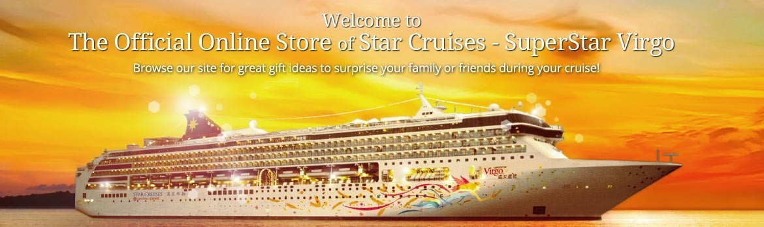

a. SuperStar Virgo's Shop and Cruise is now Online

Browse our site for great gift ideas to surprise your family and friends during your cruise! You can now purchase your favorite Shore Excursions online too! *(For SSV only) just log on to: http://shop.starcruises.com/index.php/

SUPERSTAR LIBRA AND SUPERSTAR VIRGO SPECIAL CRUISES

Sail with the Seas as SuperStar Virgo and SuperStar Libra brings you to a memorable special cruise itinerary!
Cruise on the magical waters of Southeast Asia on the magnificent SuperStar Virgo with Star Cruises’ Freestyle Cruising that offers you total freedom. Discover a fascinating blend of culture, history and adventure as you set sail to explore some of the most enchanting and exotic destinations in the region. The charm and mystery of Southeast Asia beckons you to experience its extraordinary colours and wonders.

Ko Samui, Thailand
Golden beaches, sapphire seas, coral reefs and abundant marine life, these are the ingredients that make up a tropical paradise.
And you'll find them all at Ko Samui. There are also modern embellishments such as water sports, snorkeling and scuba diving. Or you can opt to explore the island's culture, traditions and cuisine.

Escape the stress of everyday life, as SuperStar Libra brings you to a world-class exclusive floating resort on the high seas offering you an impressive array of facilities, entertainment, recreational activities and services coupled with warm Asian hospitality, which have become the hallmarks of Star Cruises.

Yangon, Myanmar
One of the more distinctive country in Southeast Asia, possessing what is quite possibly the most awe-inspiring religious monument in the region. The stunning Shwedagon Paya is the centerpiece of the city, a gleaming golden stupa visible from all over town. Closer to the waterfront, downtown Yangon is a warren of historic streets showcasing some of the best British colonial-era architecture in this region.
Book your cruise now! log on to www.starcruises.com for more details

----------------------------------------------------------------END---------------------------------------------------------------------

