TGL – Jan-Feb Issue-RWM
美好生活 – 1 至 2月份刊期 – 马尼拉云顶世界
- RWM Cover
马尼拉云顶世界封面
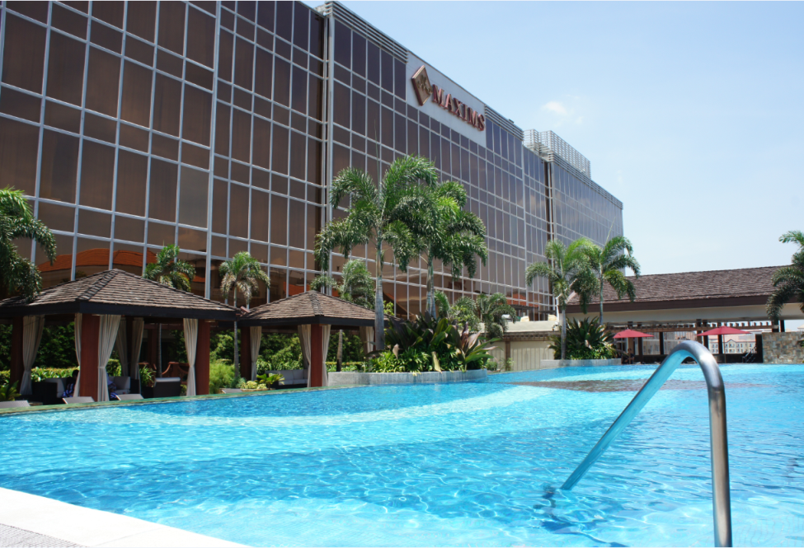

All Suite Stay at Maxim's Hotel
美星酒店全套房住宿体验

From the upscale Asian lodging brand of the Genting Group, Maxims Hotel is the all-suite luxury hotel in the Philippines, setting the benchmark for high-end accommodations in the country. Catering to guests with the most discerning tastes, this first-class city retreat is equipped with 172 spacious and lavishly-furnished suites.
作为亚洲高档住宿品牌云顶集团旗下的酒店，美星酒店是一家地处菲律宾的全套房豪华酒店，其高端的住宿品质在该国立下崭新的标竿。为满足客人最独到的品味，这家顶级都市休闲酒店拥有 172 间宽敞及装潢华丽的套房。
Complementing the plush amenities is its impeccable, personalized service. Each room is assigned a butler to attend to the guests’ every need, from their itinerary to dining reservations, 24 hours a day.
除了豪华设备之外，还有的是其无可挑剔的个性化服务。每间套房都有一个管家照料客人的各种需求，从行程安排到餐厅订位，提供全天候的服务。
For VVIPs, there are three royal villas available. A Maxims Hotel Royal Villa offers over 500 square meters of personal leisure space, with a magnificent pool, impressive patio, and an elegant kitchen and dining room for you to hold your intimate dinners. Adding to its enticing indulgences, each Maxims Hotel Royal Villa has its own massage room, offering a relaxing respite to hotel guests.
酒店准备了三间皇家别墅来招待我们的特别贵宾。美星酒店皇家别墅提供超过500平方米的个人休闲空间，包括华丽宽敞的游泳池、令人为之赞叹的庭院及供您和至亲密友共进晚餐的雅致厨房与饭厅。除了这些诱人的享受，每间美星酒店皇家别墅均拥有各自的按摩室，为酒店客人提供放松的舒适空间。
The pinnacle of luxury at Maxims Hotel is its Presidential Suite. This 600 square-meter suite is a veritable urban oasis with two pavilions, its own lush garden and a private swimming pool. Only the choicest amenities ensure utmost comfort in its two spacious bedrooms with individual bathrooms, and the master bathroom with its own jacuzzi. The Maxims Hotel Presidential Suite is the ultimate luxurious escape, with its private massage room, visual room, bar and other top-of-the-line features that will surely make your stay a one-of-a-kind experience.
美星酒店的豪华尖塔即是它的总统套房。面积有 600 平方米的套房，是名副其实的城市绿洲，内有两个亭子、苍翠繁茂的花园及私人泳池。它的设备均是一时之选，两间宽敞的卧房均附有单独的浴室，主浴室里还设有按摩浴缸，保证能令贵宾获得至高无上的舒适享受。美星酒店总统套房还备有极致奢华的休闲设备，包括私人按摩室、影视厅、吧台及其他顶级设施，必将为您带来独一无二的尊荣体验。

For inquiries and reservations, Call us at:
+63(2) 908 8000 loc 7796 to 7797
+63(2) 908 8600
欲查询或订房，请致电：
+63(2) 908 8000 转 7796 至 7797
+63(2) 908 8600
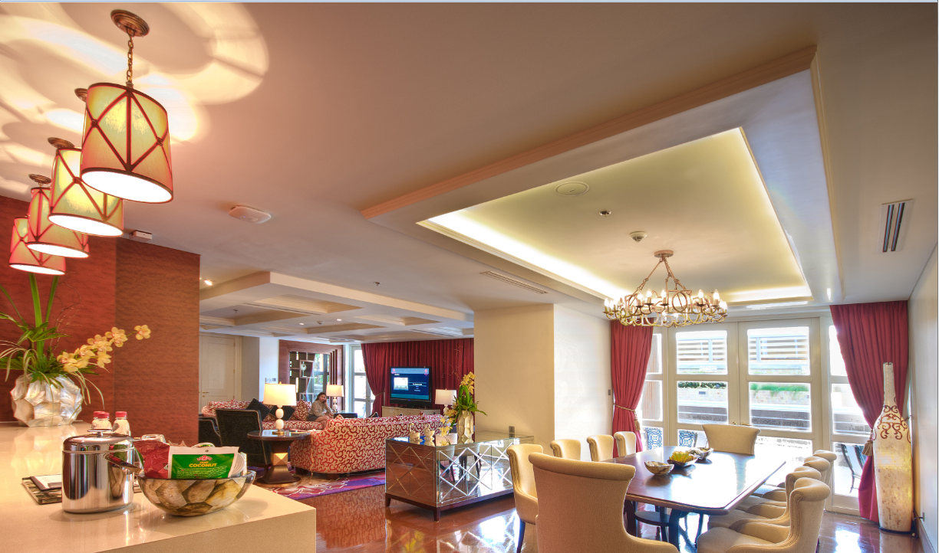

Banner Ad

iGrab

Exclusive Online Shopping UP TO 75% OFF on Limited Offers

独家网上购物限定优惠，享有高达75%折扣

Enjoy an online shopping site that provides access to handpicked products, services, and experiences at special prices.

购物网站备有特别优惠的精选产品、服务与体验供您选购，让您尽享其中的购物乐趣。

iGrab is exclusive to its members, but signing up is free. Register Now! and start shopping online! visit www.igrab.ph

iGrab 是会员专属的购物网站，可免费注册。请立即注册并开始享受网上购物的 乐趣！欢迎浏览 www.igrab.ph



- RWM Exclusive Dining Guide
马尼拉云顶世界专属美食指南
- Dine with Points
使用积分享用美食
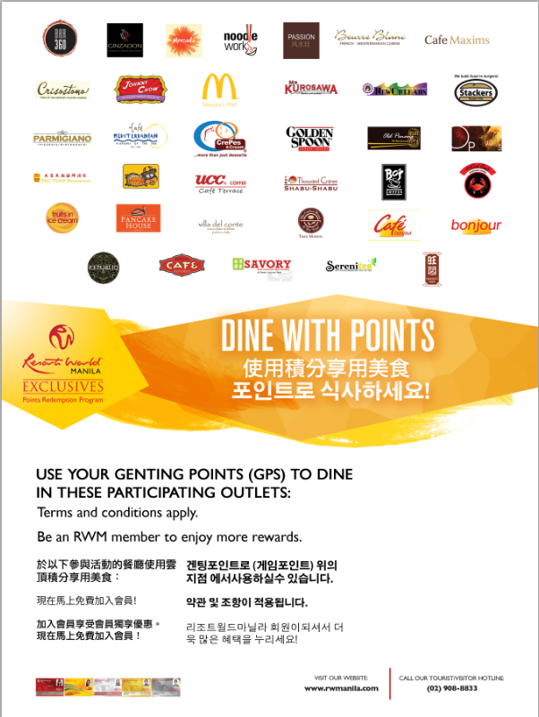

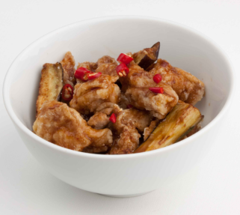

B. Recipes


Recipes' bestseller, General's Chicken, has deep fried chicken fillets and eggplant slices with Recipes' own sweet spicy sauce. General's Chicken (Not Spicy) and General's Tofu are also available.
Recipes 最畅销的料理 —— 将军鸡 —— 使用酥炸鸡柳与茄片搭配 Recipes 自制甜辣酱。另外，Recipes还有不辣版的将军鸡和将军豆腐，供您选择。

C.. Krazy Garlik
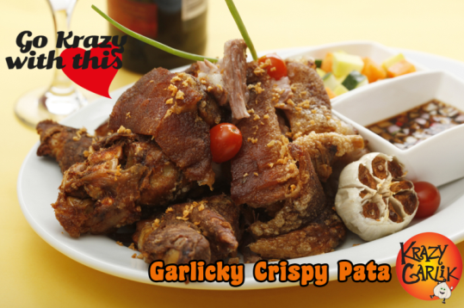
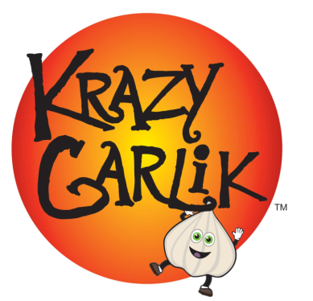
Go on a garlic adventure! Krazy Garlik brings together the best garlic recipes from around the klove.
展开一场刺激的大蒜历险之旅吧！Krazy Garlik 汇集了世界各地最棒的大蒜食谱，让您大饱口福。

Contact Details:
Krazy Garlik, Newport Mall, 2nd Level
(02) 621-7148
联络方式：
Krazy Garlik，新港商城 2 楼
(02) 621-7148

D. Savory Chicken 香草酒家


Our celebrated chicken is marinated in special seasoning and spices then fried to perfection. For a truly delighted Savory experience, indulge in our timeless gravy as you take tender bites from our juicy and tasty recipe.
我们的招牌炸鸡是采用特殊调味料及辛香料腌制，然后再炸至金黄酥脆。一口咬下嫩滑多汁的 Savory 经典口味炸鸡，让您满口幸福滋味。

Contact Details:
Newport
407-8384

联络方式：
新港
407-8384

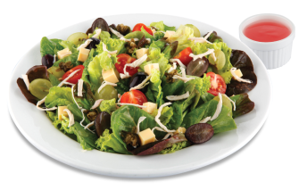
E.Pancake House


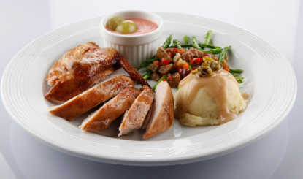

Roast Chicken with Grape Sauce is a roast chicken with a special grape sauce and two side dishes of mashed potato topped with fried capers and asparagus with grape-veggie salsa.
葡汁烤鸡，是淋上特制葡萄酱汁然后烘烤而成的鸡肉，并搭配撒上炸酸豆的马铃薯泥及芦笋佐葡萄-蔬菜莎莎酱。
Grapes and Greens Chicken Salad is a fresh mixed greens tossed with black & green grapes, roast chicken strips, cherry tomatoes, cheddar cheese and fried capers. Served with a refreshing raspberry vinaigrette.
葡萄蔬菜鸡肉沙拉，采用新鲜综合蔬菜伴黑葡萄、绿葡萄、烤鸡肉丝、小番茄、切达芝士及炸酸豆，并与清爽的覆盆子酒醋一同呈上。
Contact details:
G/F Star Cruises Centre (Across Naia 3)
100 Andrews Ave., Newport City, Pasay
Tel. No. 836-9261
联络方式：
丽星邮轮中心底层 （Naia 3 对面）
100 Andrews Ave., Newport City, Pasay
电话：836-9261

F.Tao Yuan (you can use more photos) 太皇
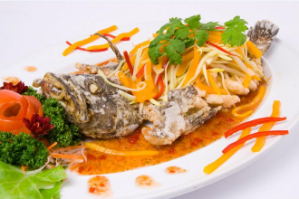



End your search for the best Hainanese Chicken Rice in town
无需再搜寻，城内最美味的海南鸡饭就在此处

G. Thousand Cranes (you can use more photos) 千羽鹤
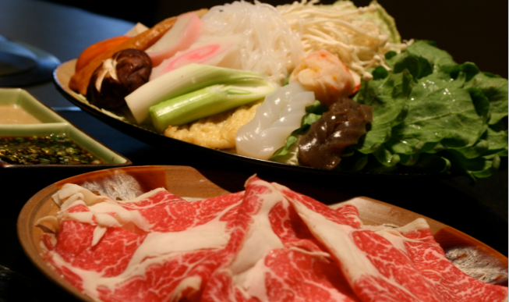



Bond over a hearty shabu-shabu meal made with the freshest ingredients and cooked right at your table.

享用一顿采用最新鲜食材并直接在桌上烹制的丰富涮涮锅大餐。
Tel No:(+632) 621 0979
Operating Hours: Daily, 11:00 a.m. - 12:00 m.n.
Location:4th Level, Newport Mall
电话：(+632) 621 0979
营业时间：每日上午 11:00 点至凌晨 12 点
地点：新港商城 4 楼

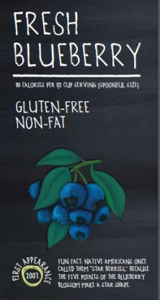
H. Golden Spoon


New flavor - st patrick's mint - "Get the luck of the Irish with this mighty minty treat."
新口味 – 圣派屈克薄荷 – “尝一口薄荷口味优格，汲取如爱尔兰幸运星一样的神奇力量。”
Jan-Feb flavor - fresh blueberry -" Enjoyed with great popularity around the world in cuisines from Asia to the Mediterranean, our blueberry flavored frozen yogurt is spot on with this nutritional powerhouse."
一、二月份口味 – 新鲜蓝莓 – “从亚洲至地中海料理，蓝莓的配搭深受各国人的喜爱，我们的蓝莓口味冻优格更是对准众人口味，是补充营养的理想点心。”
Golden Spoon Newport,
4th Floor Wall Shop 01,
Newport City, Pasay City

Golden Spoon
新港商城 4 楼 Wall Shop 01,
Newport City, Pasay City

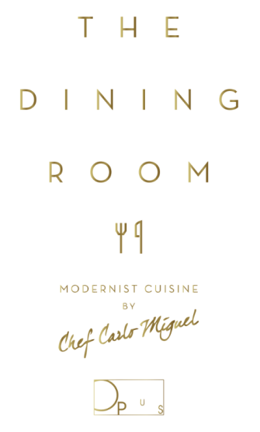
I. Opus
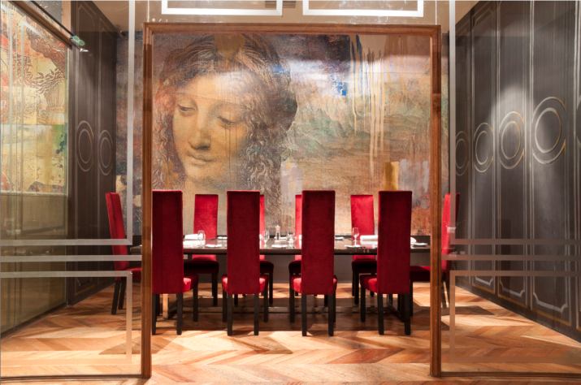

At The Dining Room at Opus, Chef Carlo Miguel takes his brand of modern European cuisine to the next level through forays in molecular gastronomy. It's not fine dining, he insists. It's fun dining!
在 Opus 的用餐大厅，享受主厨 Carlo Miguel 的拿手现代欧洲料理，欣赏他如何利用分子厨艺将美食带到新的层次。他坚持，这不是高级料理，而是趣味料理！

- RWM Events and Entertainment
马尼拉云顶世界活动与娱乐

  - Club Mwah


Catch Follies De Mwah at 8 PM this October 29, 30 and 31; November 5, 6, 7, 12, 13 and 14; and January 2, 3, 9, 10, 16, 17, 23, 24 and 31 at the Newport Performing Arts Theater!

欢迎于 10 月 29、30、31 日；11 月 5、6、7、12、13、14 日；以及 1 月 2、3、9、10、16、17、23、24、31 日，晚上 8 点，前往新港表演艺术剧场观赏 Follies De Mwah的精彩演出！
Follies De Mwah is the resident performing group of Club Mwah (located along Boni Avenue in Mandaluyong City) which has received acclaim for its Las Vegas, Moulin Rouge and Broadway-inspired musical productions, created, choreographed and directed by Cris Nicolas.

Follies De Mwah 是 Club Mwah（位于曼达卢永市博尼大街上） 的常驻剧团，其歌剧创作从拉斯维加斯、红磨坊及百老汇表演中汲取灵感，深获好评。音乐制作、编舞及导演为 Cris Nicolas。
In store for Resorts World Manila audiences are lavish numbers starting off with a take on Madonna’s Super Bowl Halftime Show; a spoof of Rodgers and Hammerstein’s The Sound of Music; Diamonds Are Forever, the Moulin Rouge version; and a whole lot more!

特别为马尼拉云顶世界的观众献上独一无二的精彩演出，当中包括麦当娜的超级杯中场演出、罗杰斯和汉默斯坦的《音乐之声》、红磨坊版《永恒之钻》及更多精彩表演！

Visit www.rwmanila.com for more details

欲知详情，请浏览 www.rwmanila.com


  - Dance Wednesdays 热舞周三

Enjoy an evening of ballroom dancing and groove to the rhythm of the 60s, 70s and 80s as Resorts World Manila presents Dance Wednesdays.
马尼拉云顶世界推出的热舞周三活动，让所有人尽情随着 60、70 及 80年代的热门音乐一起舞动起来。
Join us every Wednesday as the Spirit of 67 livens up the dance floor at Bar 360, featuring Kokoo Gonzales, Zoe Zuniga, Charlie Ysmael, and Tony Sabalza. And to make sure you are grooving to every beat, dance instructors will be on the floor to help you with your moves. Party the night away and sing along with the Spirit of 67 only at Bar 360!
每周三与我们一起在Bar 360欣赏Spirit of 67的精彩演出，表演嘉宾包括Kokoo Gonzales、Zoe Zuniga、Charlie Ysmael 及 Tony Sabalza。现场还有专业的舞蹈教练会在舞池当中指导简单的舞步，绝对让您随音乐舞动起来。彻夜狂欢，欣赏Spirit of 67劲歌热舞尽在Bar 360！
Visit www.rwmanila.com for more details
欲知详情，请浏览 www.rwmanila.com

- RWM Exclusives Shopping Guide
马尼拉云顶世界专属购物指南
  - Shop with Points
使用积分购物
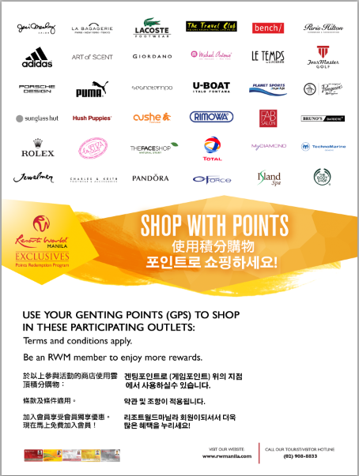

B. Velvet Salon by Jing Monis Jing Monis
丝绒沙龙


Jing Monis' mission in life is simple: "To bring out the true beauty that lies within each woman/man through my craft." Versatility is also shown in the new prestigious location, with its talented and creative team of Jing Monis Salon Velvet. We are ready to help you recreate your image and make you feel like royalty.
Jing Monis 毕生的使命很简单：“通过我的技艺，将每位女士或男士的内在美丽展现出来。”在才华洋溢且极具创意的 Jing Monis 丝绒沙龙团队的打造下，为您量身订制出各类风格。我们已做好准备为您塑造新形象，让您体验贵族般的极致享受。

www.thejingmonissalon.com

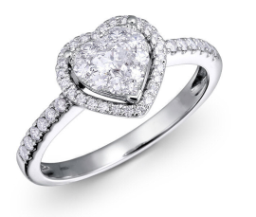
C. My Diamond

My Diamond is a concept boutique specializing in stylish white gold and diamond jewelry. My Diamond appeals to young, empowered women with discerning tastes and who know what they want in life.
My Diamond 是一间专营时尚白金和钻石首饰的概念精品店。年轻、眼光独到及明智的女性，均被My Diamond的饰品深深吸引。
Ground Floor Maxims Hotel
美星酒店底层

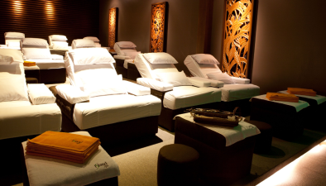

D. ISLAND SPA- A Refreshing Haven ISLAND SPA — 您的舒享天堂

Immerse yourself in Island Spa’s Zen-like ambience and the soothing feeling of well-trained hands to envelop you in feeling of total relaxation, rejuvenation and wellness.
沈浸在 Island Spa 丝丝禅意的宁谧氛围中，在专业手法的按摩下完全舒心怡神，尽享全身心的呵护。
Island Spa offers authentic Chinese Therapeutic Foot Reflexology, Shiatsu, Swedish, Deep-Tissue Massage, Aromatherapy and Volcanic Rock Massage.
Island Spa 的服务项目包括正宗的中式足底按摩、指压、瑞典式深层肌肉按摩、芳香疗法及火山岩按摩。
Refresh and rejuvenate the senses at Island Spa, an oasis in the midst of the city.
犹如城市中的一座静谧绿洲，置身于Island Spa让您获享极致的身心灵放松。
---------------------------------------------------------END---------------------------------------------------------------------

