SPREADING FESTIVE WARMTH TO THE NEEDY

In the name of tradition, most Chinese families come together every Lunar New Year for a decadent reunion dinner. For some TOUCH clients that lack that privilege, our corporate and school partners stepped in to be that family for them.

LNY dinner at Grand Mercure Roxy Hotel
On 6 February, 40 students from Nanyang Girls’ Boarding School (NYGBS) hosted 200 needy children and elderly beneficiaries from TOUCH Community Services at a reunion dinner held at Grand Mercure Roxy Hotel. Sponsored by Roxy-Pacific Holdings Ltd the event was graced by Associate Professor Fatimah Lateef, Member of Parliament of Marine Parade GRC.

Two elderly clients from TOUCH Home Care who were wheelchair bound also arrived at the dinner in style with the Executive Directors of Roxy Pacific as their personal chauffeurs for the day.

In the comfort of the ballroom, the clients of TOUCH were treated to a myriad of performances, such as melodious tunes from guzheng and pipa ensembles, song and dance items by NYGBS students, as well as energetic dance performances by TYA and TSAC.

As a token of well-wishes, Assoc Prof Fatimah Lateef, Mr Teo Hong Lim, Chairman of Roxy Pacific Holdings Ltd, and Mr Dominique Albero, General Manager of Grand Mercure Roxy Hotel went around the ballroom to distribute red packets to the TOUCH clients and their families.

With smiling faces all around, this reunion dinner proved to be a joyous occasion not only for the clients of TOUCH but also for the NYGB students who were away from their families. Says NYGBS student, Tang Yi Bei, “Being away from home, I miss my family dearly especially during the Lunar New Year. Volunteering at this event has made me feel like a part of a huge family and has also given me a sense of fulfillment when I see the happy faces of the TOUCH clients.”

“I enjoyed myself and am very glad to witness the positive energy as we spread the festive cheer to the clients of TOUCH!”
- Assoc Prof Fatimah Lateef, Guest-of-Honour and Member of Parliament, Marine Parade GRC

“This reunion dinner has showed our girls that despite being away from home and their families, they too can enrich the lives of the less privileged no matter where they may be.”
- Mrs Kong Fang-Yu, NYBGS Staff

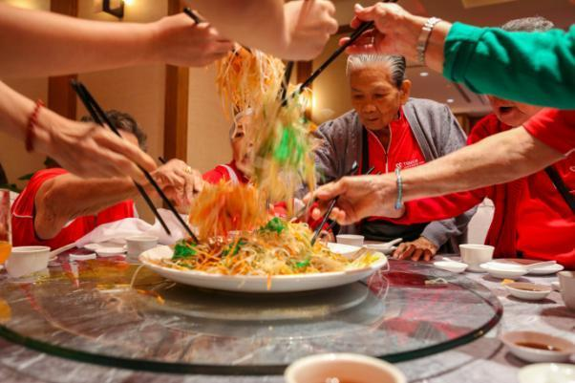
Elderly clients of TSAC tossing the “Yu Sheng”, a traditional Lunar New Year dish.
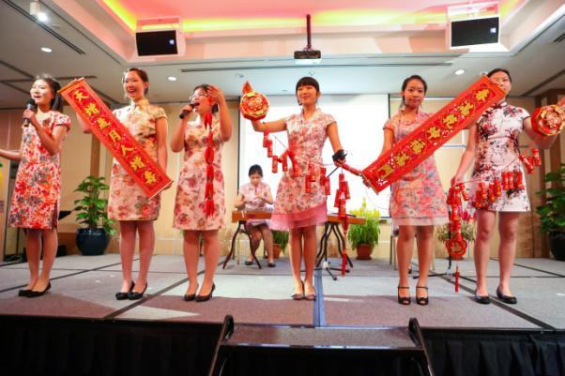
NYGBS students performing a Lunar New Year song.
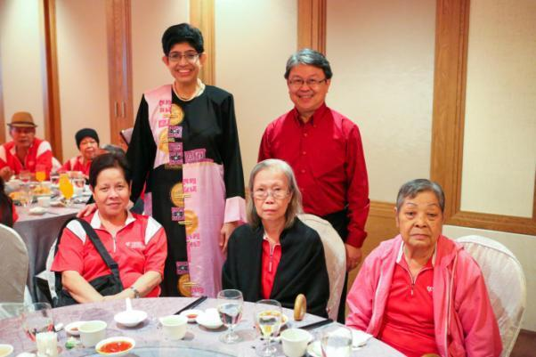
Guest-of-Honour Assoc Prof Fatimah Lateef, MP for Marine Parade GRC and Edmund Wong, General Manager of TOUCH Community Services, with elderly clients of TSAC.

BONDING OF GENERATIONS OVER LUNAR NEW YEAR

To bring joy to the elderly during the festive season, students from Paya Lebar Methodist School (PLMGS) played host to 90 less privileged seniors from TOUCH Seniors Activity Centre (TSAC) within the school compound on 22 February where they doubled up as ushers, escorts and even waitresses for the evening. This is the fourth year the school is collaborating with TOUCH to bring cheer to the needy over the Lunar New Year period.

The seniors were enthralled by the various performances by the students such as guzheng and dance items, crosstalk, and even a Hokkien song item. Proving that the elderly can still be fit and agile, the TSAC clients also presented a dance item of their own and had everyone clapping along.

The interaction between the two generations was indeed meaningful and the seniors and students thoroughly enjoyed each other’s company. Hugs were exchanged at the end of the evening when the seniors finally took their leave.

“PLMGS holds a very special place in our heart. The girls are endearing and attentive, and the seniors always look forward to meeting them!”
- Julia Lam, Director of TOUCH Seniors Activity Centre

